**DevOps**

**GIT AND GITHUB**

**==============**

Git(Global Information tracker):

================================

- Git is a DevOps tool used for source code management.

- It is a free and open-source version control system used to handle small to very large projects efficiently.

- Git is used to tracking changes in the source code.

- In this we have 3 types version

1.Local version

2.Centralized version

3.Distrubuted version

- Local version:

- Which code will develop in local machine(PC).

- Centralized machine: It stores the data in the remote repository (central machine) not in the

local machine.

- Distributed version: This is also a version controller and saved in the remote repo and local

Machine.

**NOTE**: The **main difference** between centralized and distributed version control is that, **in centralized version control, the versions are saved in the remote repository, while in distributed version control, versions can be saved in the remote repository as well as in local repositories of the local machines.**

**Remote repository: such a remote repository is stored on a code hosting service like GitHub**

(GitHub and remote repository are same).

GITHUB:

=======

* GitHub is **a code hosting platform for version control and collaboration**. It lets us and others work together on projects from anywhere.

git installation

github account creation

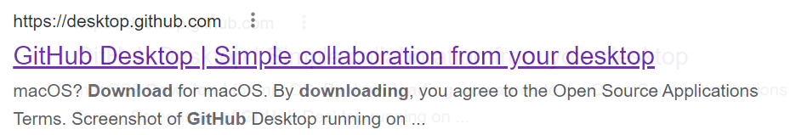

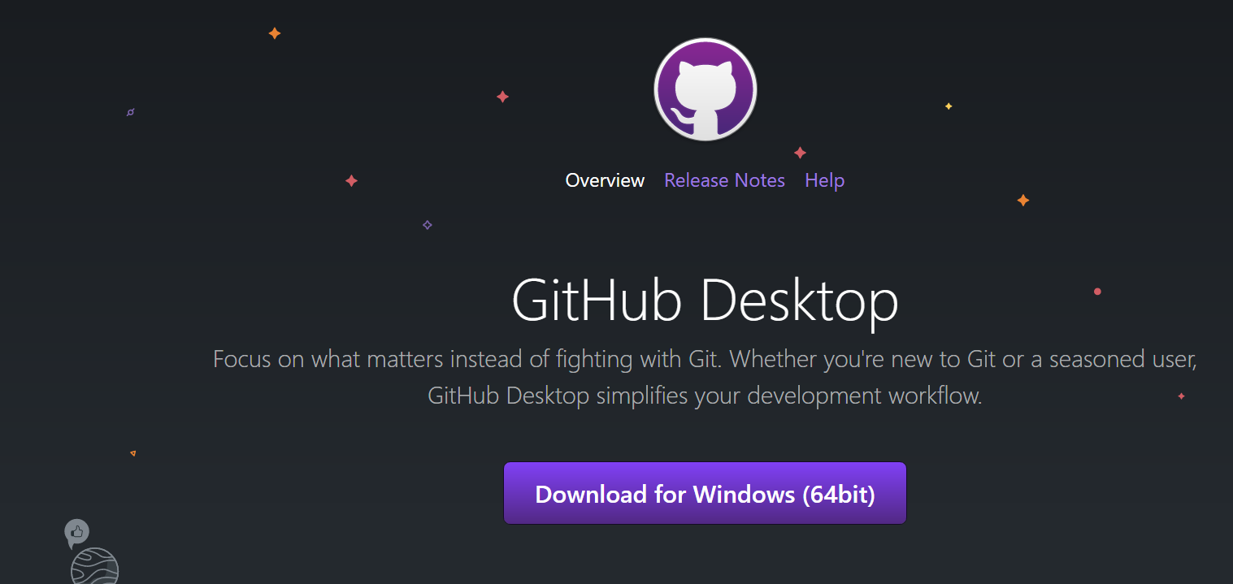

After installation of the GITHUB you can find the below home page

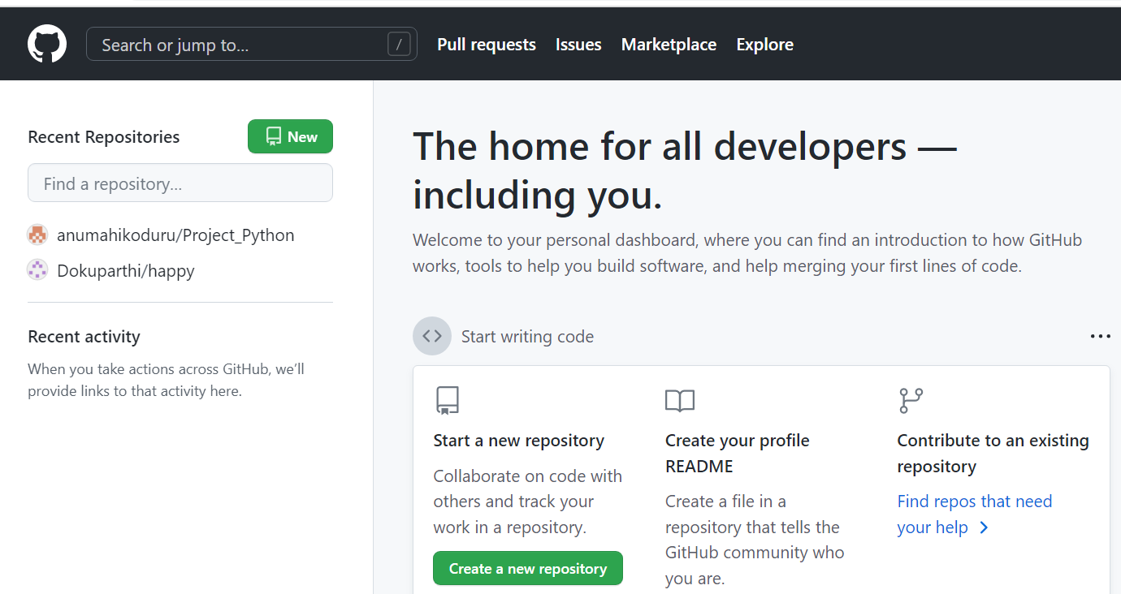

Go to the Github settings click on the image (blue color) you can see the dropdown



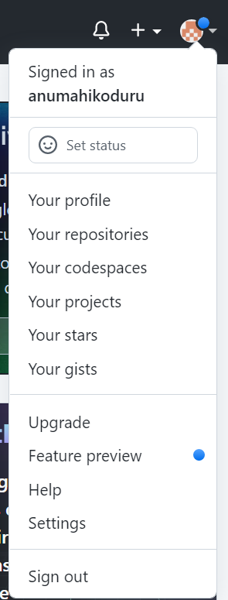

Click on Github settings for the token generation

Click on developer setting

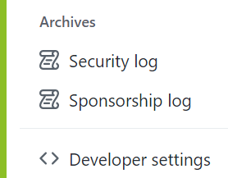

Click on Personal access token

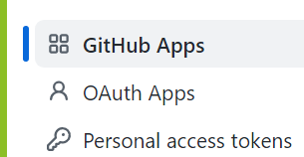

Click on generate new token



This token is used for to push the code

TO CREATE THE NEW REPOSITORY

To click on the create repository or NEW

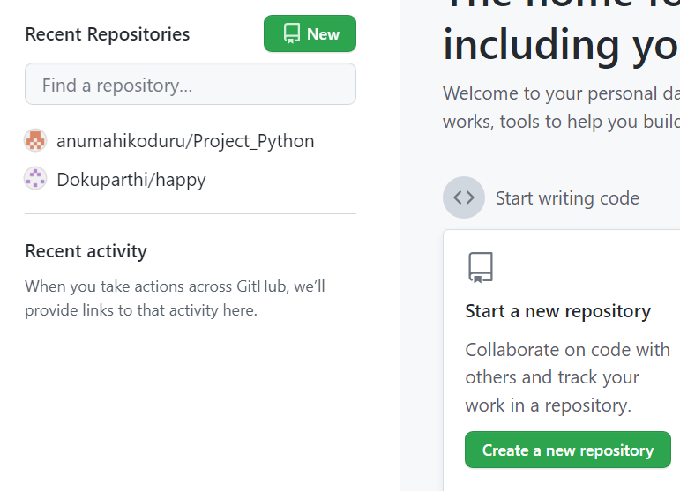

You need to give the project or repo name

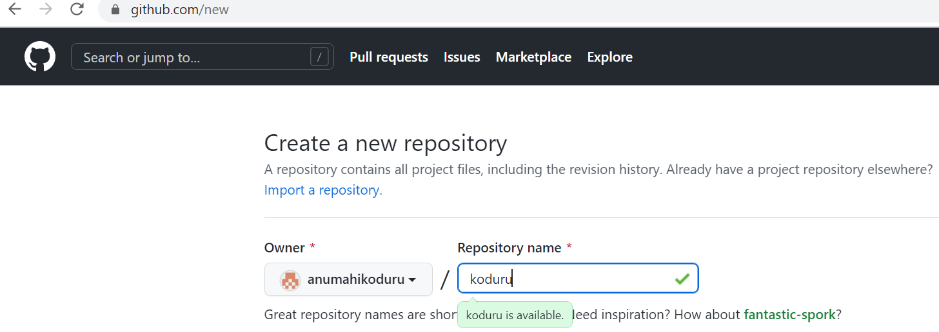

As of now we are selecting the Public where as in Organization we will select private for security reasons

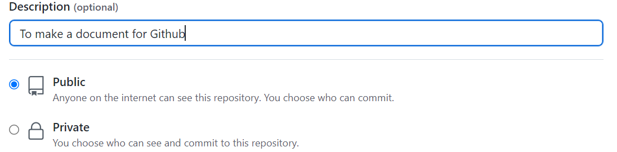

Click on 

Now you can find the url



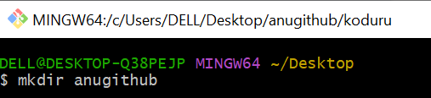

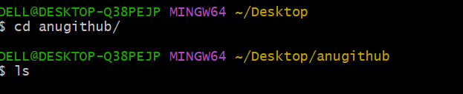



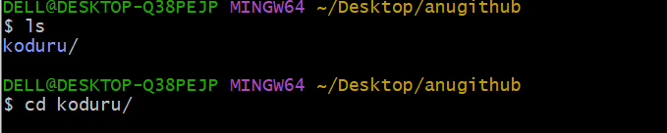

 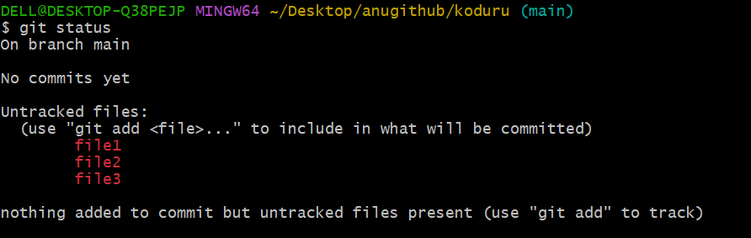



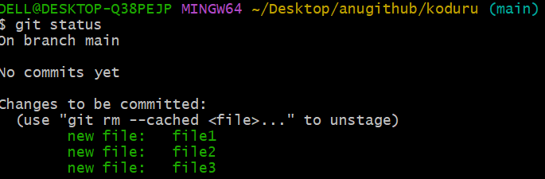





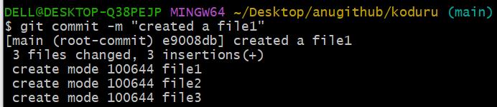



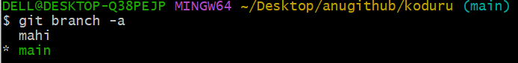

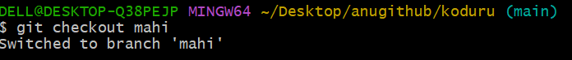

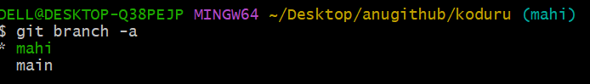

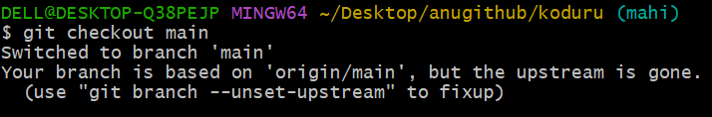

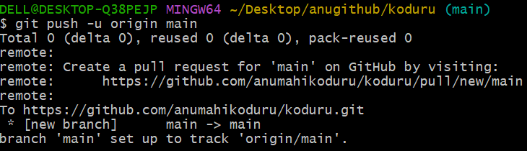



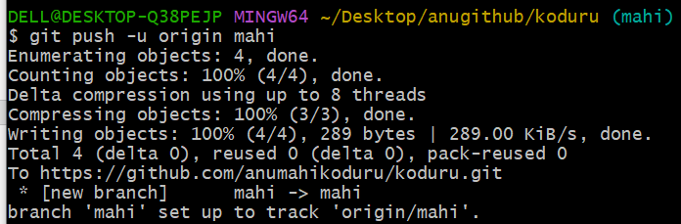



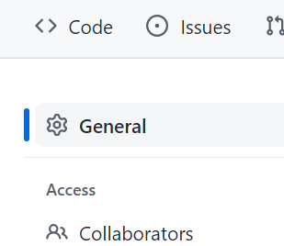

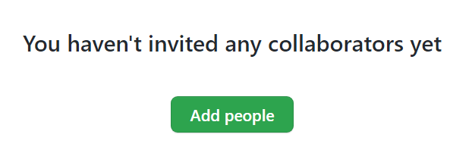

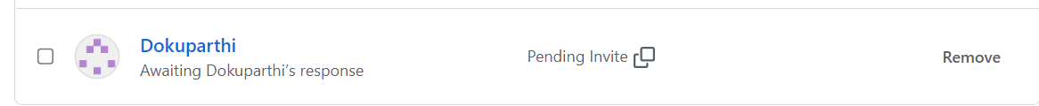

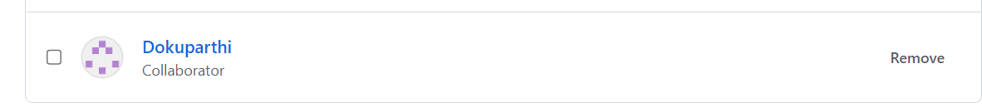

Edit the code in branch section(mahi) not in the main branch ---NEED TO BE EDIT THE SENTENCE

